SOFTWARE ARCHITECTURE MERMAID DIAGRAM ACTIVITIES
Question 1 – Online Library System
A university library has an online system. Students use a Web Application to search for books and borrow them. The Web Application communicates with an Application Server, which retrieves book information from a Library Database.
Task: Identify the four main components and create the Mermaid architecture diagram. Write your Mermaid code in the space provided.
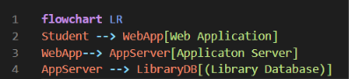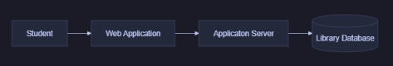
Question 2 – Student Registration System
A university has an online student registration system. Students access it through a Web Application. The Web Application communicates with an API. The API communicates with the Application Server. The Application Server stores student information in a Student Database. Teachers also use the Web Application to view student information.
Create a Mermaid architecture diagram showing the components and connections. Should both Student and Teacher connect to the Web Application? Create it accordingly.

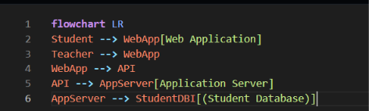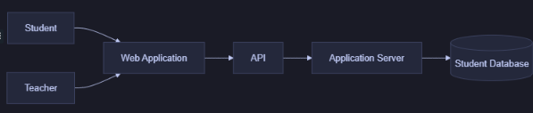
Question 3 – Online Food Ordering System
A customer uses an online food ordering application. The system contains Customer, Mobile/Web Application, API, Restaurant Service, Order Service, Payment Service, Restaurant Database, Order Database, and Payment Gateway. The customer places an order through the application. The application communicates with the API, which communicates with the appropriate services.
Create a Mermaid architecture diagram showing how these components are connected.

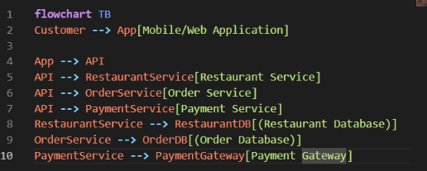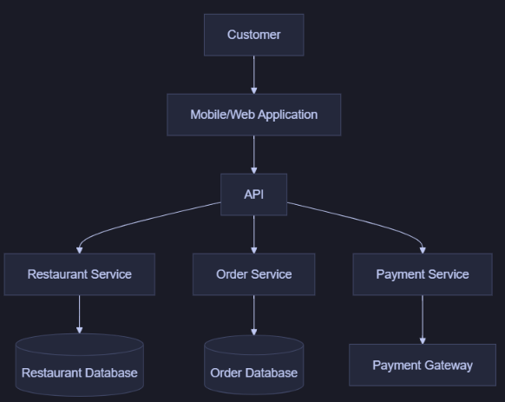
Question 4 – Online Shopping System
An online shopping system has Customer, Web Application, API, Authentication Service, Product Service, Order Service, User Database, Product Database, Order Database, Payment Service, and Payment Gateway. The customer logs in, views products, places an order, and makes a payment.
Create a complete architecture diagram showing the major components and their relationships. Do not connect every component to every other component; connect only components that need to communicate.

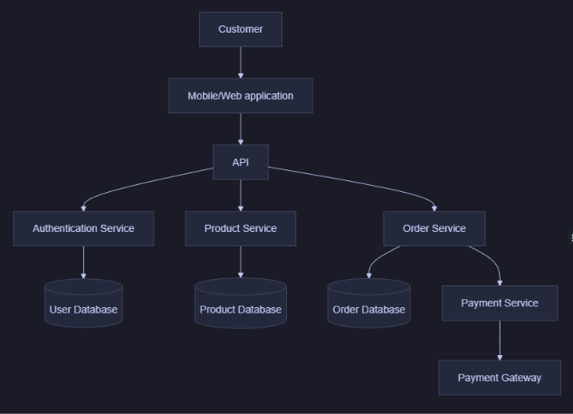

Question 5 – Design Your Own Architecture
Choose one system: Hospital Appointment System, Cinema Booking System, Hotel Booking System, University Learning Management System, or Online Banking System.
Your system must contain at least 8 components.
Give your system a name.
Identify at least 8 components.
Identify at least 2 databases or external services.
Decide how the components communicate.
Write the Mermaid code and generate the architecture diagram.
Components:
1 User interface
2 user account management
3 Hotel Search
4 Room Availability
5 Booking Management
6 Payment Processing
7 Notification Service
8 Hotel Management

2 databases:
- Booking database
- Payment gateway

Your Mermaid code: 